HAVE A NICE

SUMMER
SONG BOOK

Summer 2014

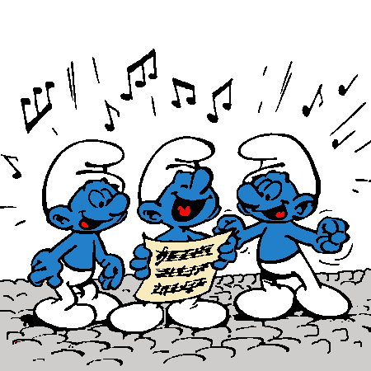

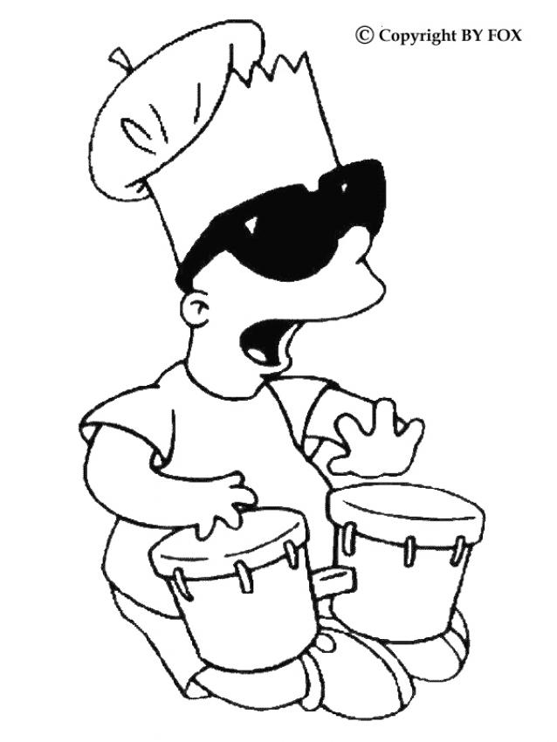

NOTES
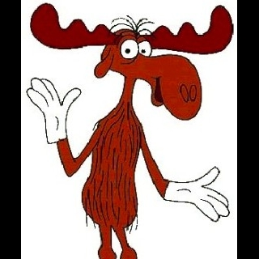The Great Big Moose

There was a great big moose (repeat)
Who used to drink a lot of juice (repeat)
Chorus: Say Wo Oh oh (repeat)
Wee-Oh wee-oh wee-oh wee-oh (repeat)
Wo oh oh oh (repeat)
Wee-Oh wee-oh wee-oh wee-oh (repeat)
And is name was Fred (repeat)
He used to drink his juice in bed (repeat)
Chorus
He drinks his juice with care (repeat)
But he spit it everywhere (repeat)
Chorus
He was a sticky moose (repeat)
Cause he spit a lot of juice (repeat)
There was a great big moose (repas
Driiinkiiing juuuuuuice !!!! (all together))

Flea

Flea (repeat)
Flea fly (repeat)
Flea fly flow (repeat)
Feasta (repeat)
Cooma lotta cooma lotta cooma lotta feasta (repeat)
Oh no, no, no, na feasta (repeat)
Esca meany sala meany Oh-ah do ah-la meany (repeat)
Esca meany sala meany Oh-ah do ah (repeat)
With an epp bidily oatin doatin bo-dope skid eatin dats a what I can chew (repeat)
The Frog Song

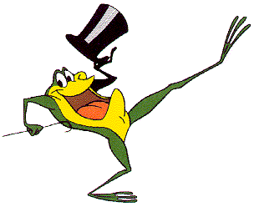3 faces : 1- Hum != eyes closed
2- Hu ! eyes opened and tongue out
3- Ah != say Ah

Hum! Hu!
Went a little green frog, one day
Hum! Hu!
Went a little green frog
Hum! Hu!
Went a little green frog, one day
So we all went
Hum! Hu! Ah!
But we all know frogs go
Cha la la la la, cha la la la la
Cha la la la la
We all know frogs go
Cha la la la la
They dont go
Hm! Hu! Ah!

B-I-N-G-O

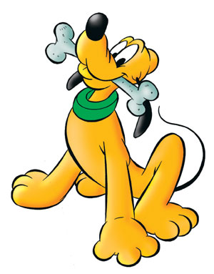There was a farmer who had a dog,
And Bingo was his name-O!
B-I-N-G-O!
B-I-N-G-O!
B-I-N-G-O!
And Bingo was his name-O!
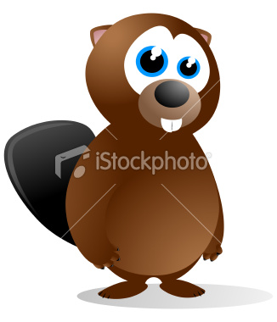Beaver Song

Beaver 1, Beaver all
Let’s all do the beaver Call
Tsch!, tsch!, tsch!, tsch!, tsch! tsch!, tsch!

Beaver 2, Beaver 3
Let’s all climb the beaver Tree
Tsch!, tsch!, tsch!, tsch!, tsch! tsch!, tsch!

Beaver 4, Beaver 5
Let’s all do the Beaver Jive
Tsch!, tsch!, tsch!, tsch!, tsch! tsch!, tsch!

Beaver 6, Beaver 7
Let’s all go to Beaver Heaven
Tsch!, tsch!, tsch!, tsch!, tsch! tsch!, tsch!

Beaver 8, Beaver 9
Stop !
It’s Beaver Time

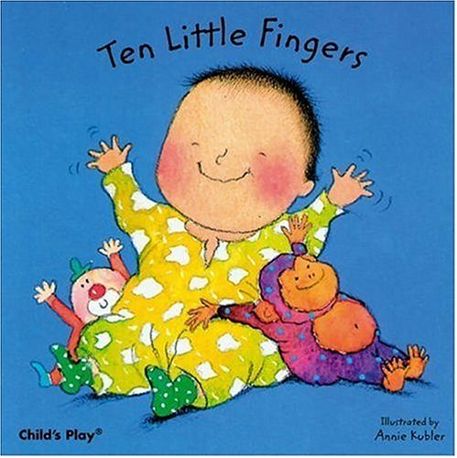10 Little fingers

1 little, 2 little, 3 little fingers
4 little, 5 little, 6 little fingers
7 little, 8 little, 9 little fingers
10 fingers on my hands

* you can sing it the other way around also

Shoot the Moon

Monit- Can you do the Shoot the Moon?
kids- What’s that you said?
Monit- I said can you do the Shoot the Moon?
All - Shoot, the Moon,
Shoot Shoot the Moon, Pawf !
Shoot, the Moon,
Shoot Shoot the Moon, Pawf !

- Can you do the disco duck? ...
- Can you do the Frankenstein? ...
- Can you do the funky chicken?...
- Can you do the blondy girl?...

*...Use your imagination...*

If you're happy and you know it

If you’re happy and you know it, clap your hands (x2)
If you’re happy and you know it, then youri face will surely show it
If you’re happy and you know it clap your hands.

- stamp your feet
- do the train
- shout hurray
- etc...

Banana song

Peel, banana, peel peel banana
Peel, banana, peel peel banana

Chop, banana, chop chop banana
Chop, banana, chop chop banana

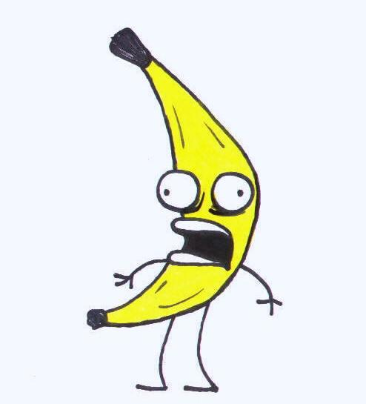Smoosh, banana, smoosh smoosh banana
Smoosh, banana, smoosh smoosh banana

Eat, banana, eat eat banana
Eat, banana, eat eat banana

Go ! Bananas, Go ! Go ! Bananas
Go ! Bananas, Go ! Go ! Bananas
Bananaaaaaaaaaaaa... SPLIT !

The Shark Song

Baby Shark, shoo-bee-do-wee, shoo-bee-do-wa
Mama Shark, shoo-bee-do-wee, shoo-bee-do-wa
Papa Shark, shoo-bee-do-wee, shoo-bee-do-wa
Lady swims, shoo-bee-do-wee, shoo-bee-do-wa
Shark attacks , Waaaaaa!!! Shark attacks , Waaaaa!!!
Swim away, shoo-bee-do-wee, shoo-bee-do-wa

My Aunt Came Back

My Aunt came back (My aunt came back)
From old Japan (From old Japan)
And she brought me back (and she brought me back)
A Japanese fan (a Japanese fan)
(Start waving right hand like a fan)

My Aunt came back
From old Hong Kong
And she brought me back
A game of ping pong
(wave left hand like ping-pong bat)

Kampuchea - Rocking Chair
(start rocking back and forward)

Timbuktu - some nuts like you
(stop actions and point at audience)

The itsy bitsy spider

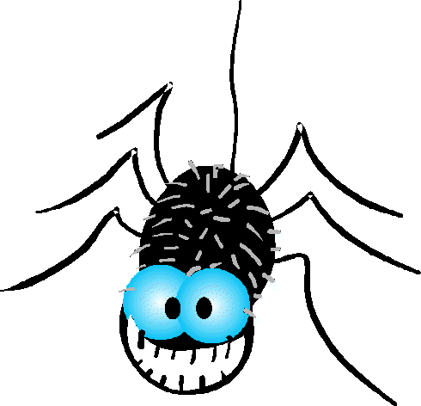The itsy bitsy spider
Crawled up the water spout
Down came the rain
And washed the spider out
Out came the sun
And dried up all the rain
And the itsy bitsy spider
Crawled up the spout again.
Boom-chick-a-boom

Boom!
Boom-a-chick-a-boom!
Boom-a-chick-a-rocka chick-a-rocka
a-chick-a-boom!
Oh yeah!
Uh! Uh!
One more time now!

Mary Had a Little Lamb

Mary had a little lamb
Whose fleece as white as snow.
And everywhere that Mary went,
The lamb was sure to go!

It followed her to school one day,
which was against the rules.
It made the children laugh and play,
To see a lamb at school.

Twinkle Twinkle Little Star"

* to the tune of the alphabet song *
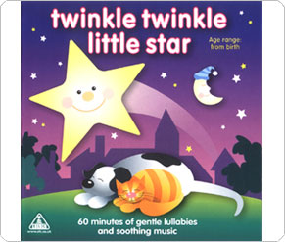
Twinkle, twinkle, little star
How I wonder what you are.
Up above the world so high,
Like a diamond in the sky.
Twinkle, twinkle, little star,
How I wonder what you are.

Pretty colors

(To the tune of Oh My Darling Clementine)

Red and orange,
Yellow, green, blue,
Purple, Brown and pink and gray
Pretty colors are all around me,
And I know each one by name !

10 Little Monkeys

10 little monkeys, jumping on the bed
1 fell off and bumped his head
Mama called the doctor,
And the doctor said:
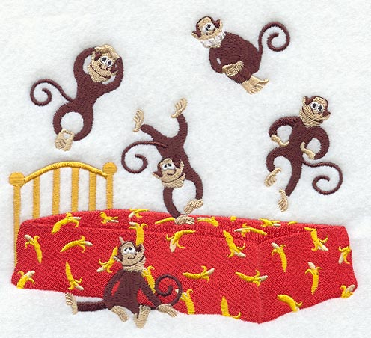No more monkeys jumping on the bed.

9 ......
8.......
7.......
Etc..

One little monkey jumping on the bed,
He fell off and bumped his head,
Mama called the doctor and the doctor said:
Put those monkeys back to bed!

MY BONNIE

My Bonnie lies over the ocean,
My Bonnie lies over the sea.
My Bonnie lies over the ocean,
Oh, bring back my bonnie to me.
Bring back, bring back,
Oh, bring back my bonnie to me, to me.
Bring back, bring back,
Oh, bring back my bonnie to me.
Last night as I lay on my pillow,
Last night as I lay on my bed,
I stuck my feet out of the window,
Next morning my neighbors were dead.
Bring back, bring back,
Oh, bring back my neighbors to me, to me.
Bring back, bring back,
Oh, bring back my neighbors to me.

Swimming Pool

Swimming, swimming, in my swimming pool
When days are hot, when days are cold
In my swimming pool!
Breast stroke, side stroke, fency diving to
Oh don’t you wish you’d never had
Anything else to do.... But

*replace one part by mmmm....Everytimes you start the song over. *
He’s got the whole world in his hands

He's got the whole world in His hands
He's got the whole world in His hands
He's got the whole world in His hands
He's got the whole world in His hands

He's got the Dainty, Dainty Daisies in His hands
He's got the Dainty, Dainty Daisies in His hands
He's got the Dainty, Dainty Daisies in His hands
He's got the whole world in His hands

He's got the Busy, Busy Brownies in His hands
He's got the Busy, Busy Brownies in His hands
He's got the Busy, Busy Brownies in His hands
He's got the whole world in His hands

He's got the Jazzy, Jazzy Juniors in His hands
He's got the Jazzy, Jazzy Juniors in His hands
He's got the Jazzy, Jazzy Juniors in His hands
He's got the whole world in His hands

He's got the Crazy, Crazy Cadettes in His hands
He's got the Crazy, Crazy Cadettes in His hands
He's got the Crazy, Crazy Cadettes in His hands
He's got the whole world in His hands

He's got the Sassy, Sassy Seniors in His hands

Down by the Bay

Down by the bay
Where the watermelons grow
Back to my home
I dare not go
For if I do
My mother will say
"Did you ever see a fly
Wearing a tie?"
Down by the bay.

Down by the bay
Where the watermelons grow
Back to my home
I dare not go
For if I do
My mother will say
"Did you ever see a bear
Combing his hair?"
Down by the bay.

Down by the bay
Where the watermelons grow
Back to my home
I dare not go
For if I do
My mother will say
"Did you ever see a moose
Kissing a goose?"
Down by the bay.

Down by the bay
Where the watermelons grow
Back to my home
I dare not go
For if I do
My mother will say
"Did you ever see a whale
With a polka dot tail?"
Down by the bay.

Down by the bay
Where the watermelons grow
Back to my home
I dare not go
For if I do
My mother will say
"Did you ever see some llamas
Eating pajamas?"
Down by the bay.

Down by the bay
Where the watermelons grow
Back to my home
I dare not go
For if I do
My mother will say
"Did you ever have a time
When you couldn't make a rhyme?"
Down by the bay.

Reach for the sky

Clap your hands, touch your toes
Turn around and put a finger on your nose
Flap your arms, jump up high
Wiggle your fingers and reach for the sky
YOU ARE MY SUNSHINE

CHORUS:
You are my sunshine, my only sunshine
You make me happy when skies are grey
You’ll never know, dear, how much I love you
Please don’t take my sunshine away
The other night, dear, as I lay sleeping
I dreamed I held you in my arms
When I awoke, dear, I was mistaken
So I hung my head and I cried
CHORUS
I’ll always love you and make you happy-
If you will only stay the same
But if you leave me to love another
You’ll regret it all someday
CHORUS

Skidamarink

Skidamarink-a-dink-a-dink
Skidamarink-a-doo, I love you!
(Repeat)
I love you in the morning
and in the afternoon,
I love you in the evening and
Underneath the moon

Skidamarink-a-dink-a-dink
Skidamarink-a-doo, I love you!
I’m a little tea pot

I'm a little teapot, short and stout
Here is my handle [one hand on hip], here is my spout [other arm out straight]
When I get all steamed up, hear me shout
Just tip me over and pour me out!
[as song ends, lean over and tip arm out like a spout]

I'm a clever teapot, yes it's true
Here's an example of what I can do
I can change my handle to my spout [switch arm positions and repeat tipping motion]
Just tip me over and pour me out

Hokey Pokey

You put your right hand in,
You put your right hand out,
You put your right hand in,
And you shake it all about,
You do the hokey pokey
and you turn yourself around
That what it's all about.
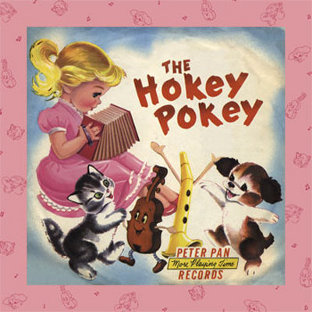2) left hand
3) right foot
4) left foot
5) head
6) butt
7) whole self
Teasing Mr. Alligator

Five little monkeys
Sitting in a tree
Teasing Mr. Alligator,
(teasing faces, hands up to face like
moose antlers or one hand in front of nose)
"You can't catch me."
Along came Mr. Alligator,
(finger up to mouth like SHHHH)
Quiet as can be
SNAP
(Both hands clap together like an alligator's mouth)

Four little monkeys
Sitting in a tree
Teasing Mr, Alligator,
"You can't catch me."
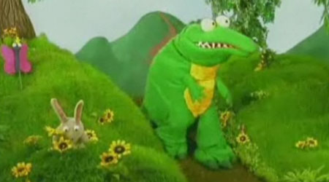Along came Mr. Alligator,
Quiet as can be
SNAP

Three little monkeys
Sitting in a tree
Teasing Mr. Alligator,
"You can't catch me."
Along came Mr. Alligator,
Quiet as can be
SNAP

Two little monkeys
Sitting in a tree
Teasing Mr. Alligator,
"You can't catch me."
Along came Mr. Alligator,
Quiet as can be
SNAP

One little monkey
Sitting in a tree
Teasing Mr. Alligator,
"You can't catch me."
Along came Mr. Alligator,
Quiet as can be
SNAP

No more little monkeys
Sitting in a tree

Missed me!
Ham and Eggs

Ham and eggs, Ham and eggs,
I like mine fried nice and brown.
I like mine fried up side down.

Ham and eggs, Ham and eggs,
Flip 'em, Flop 'em, Flop 'em, Flip 'em,
Ham and eggs!

John Jacob Jingleheimer Schmidt

John Jacob Jingleheimer Schmidt,
His name is my name too.
Whenever we go out,
The people always shout,
There goes John Jacob Jingleheimer Schmidt.
Dah dah dah dah, dah dah dah

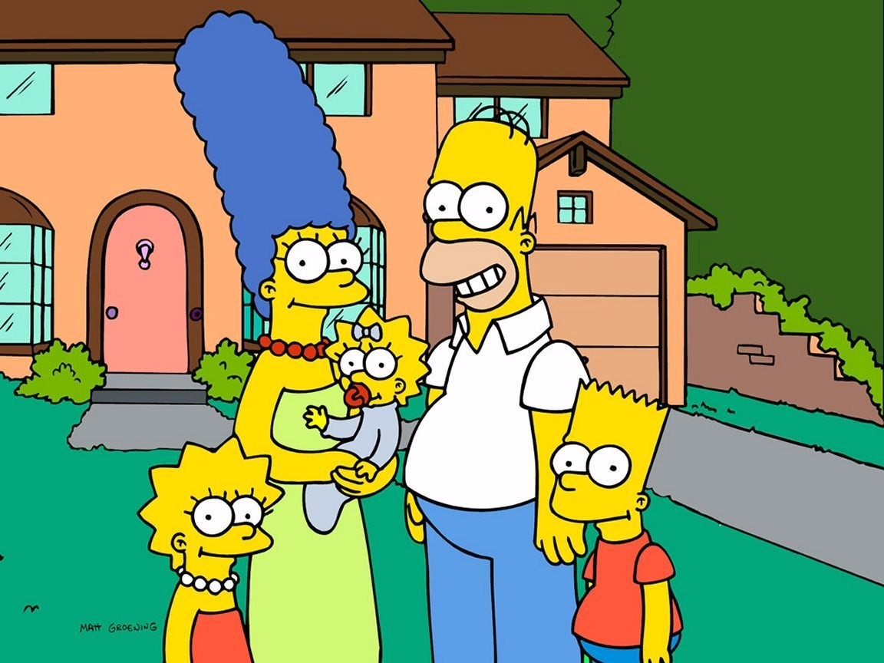

Sally the camel

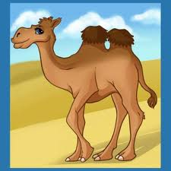 Sally the camel has five humps.
Sally the camel has five humps.
Sally the camel has five humps.
So ride, Sally, ride.
Boom, boom, boom, boom!
Sally the camel has four humps.
Sally the camel has four humps.
Sally the camel has four humps.
So ride, Sally, ride.
Boom, boom, boom, boom!
Sally the camel has three humps.
Sally the camel has three humps.
Sally the camel has three humps.
So ride, Sally, ride.
Boom, boom, boom, boom!
Sally the camel has two humps.
Sally the camel has two humps.
Sally the camel has two humps.
So ride, Sally, ride.
Boom, boom, boom, boom!
Sally the camel has one hump.
Sally the camel has one hump.
Sally the camel has one hump.
So ride, Sally, ride.
Boom, boom, boom, boom!
Sally the camel has no humps.
Sally the camel has no humps.
Sally the camel has no humps.
'Cause Sally is a horse, of course

FATHER ABRAHAM

Father Abraham
Had seven sons sir
Had seven sons sir
Had Father Abraham
And they never laughed
And they never cried
All they did was go like this...
And a right (Move right arm up and down)
Chorus -
And a left (Move left arm up and down)
Chorus -
And a right (Add in your right leg)
Chorus -
And a left (Now you will be jumping and moving arms)
Chorus -
And a head (Now move head along with arms and legs)
Chorus -
And a body (Now move entire body)
Chorus – (collapse)

This Land is Your Land

Chorus:
This land is your land, this land is my land
From California, to the New York Island
From the redwood forest, to the gulf stream waters
This land was made for you and me
As I was walking a ribbon of highway
I saw above me an endless skyway
I saw below me a golden valley
This land was made for you and me
Chorus
I've roamed and rambled and I've followed my footsteps
To the sparkling sands of her diamond deserts
And all around me a voice was sounding
This land was made for you and me
Chorus
The sun comes shining as I was strolling
The wheat fields waving and the dust clouds rolling
The fog was lifting a voice come chanting
This land was made for you and me
Chorus
As I was walkin' - I saw a sign there
And that sign said - no tress passin'
But on the other side .... it didn't say nothin!
Now that side was made for you and me!
Chorus
In the squares of the city - In the shadow of the steeple
Near the relief office - I see my people
And some are grumblin' and some are wonderin'
If this land's still made for you and me.
Chorus (2x)

Old Macdonald had a farm

Old Macdonald had a farm, E-I-E-I-O
And on his farm he had a cow, E-I-E-I-O
With a "moo-moo" here and a "moo-moo" there
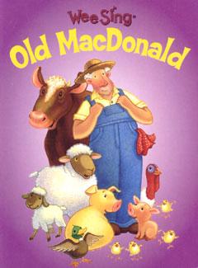Here a "moo" there a "moo"
Everywhere a "moo-moo"
Old Macdonald had a farm, E-I-E-I-O
Old Macdonald had a farm, E-I-E-I-O
And on his farm he had a pig, E-I-E-I-O
With a (snort) here and a (snort) there
Here a (snort) there a (snort)
Everywhere a (snort-snort)
Old Macdonald had a farm, E-I-E-I-O
Old Macdonald had a farm, E-I-E-I-O
And on his farm he had a horse, E-I-E-I-O
With a "neigh, neigh" here and a "neigh, neigh" there
Here a "neigh" there a "neigh"
Everywhere a "neigh, neigh"
Old Macdonald had a farm, E-I-E-I-O
Old Macdonald had a farm, E-I-E-I-O
And on his farm he had a chicken, E-I-E-I-O
With a "cluck, cluck" here and a "cluck, cluck" there
Here a "cluck" there a "cluck"
Everywhere a "cluck, cluck"
Old Macdonald had a farm, E-I-E-I-O
Old Macdonald had a farm, E-I-E-I-O
And on his farm he had a duck, E-I-E-I-O
With a "quack, quack" here and a "quack, quack" there
Here a "quack" there a "quack"
Everywhere a "quack, quack"
Old Macdonald had a farm, E-I-E-I-O
OH I WISH I WERE

*(Tune: "If You're Happy and You Know It")

Oh, I wish I were a little bar of soap.
Oh, I wish I were a little bar of soap.
I would slippy and I'd slidey,
Over everybody's hidey.
Oh, I wish I were a little bar of soap.

Oh, I wish I were a little hunk of mud.
Oh, I wish I were a little hunk of mud.
I would ooey and I'd gooey,
Under everybody's shoey.
Oh, I wish I were a little hunk of mud.

Oh, I wish I were a little can of pop.
Oh, I wish I were a little can of pop.
I'd go down with a slurp,
and come up with a burp.
Oh, I wish I were a little can of pop.

Oh, I wish I were a little slippery root.
Oh, I wish I were a little slippery root.
I would sit upon the trail,
And knock everyone on his tail.
Oh, I wish I were a little slippery root.

Oh, I wish I were a little mosquito.
Oh, I wish I were a little mosquito.
I'd buzzy and I'd bitey,
Under everybody's nighty.
Oh, I wish I were a little mosquito.
Take me out to the ball game

Take me out to the ball game,
Take me out with the crowd.
Buy me some peanuts and cracker jack,
I don’t care if I never get back,
Let me root, root, root, for the home team
If they don’t win it’s a shame.
For it’s one, two, three strikes, you’re out,
At the old ball game.

Row, row, row your boat
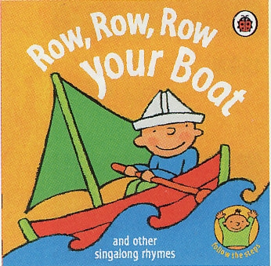
Row, row, row your boat
Gently down the stream
Merrily, merrily, merrily, merrily
Life is but a dream

(To sing in a round)

I’m a little snowman

I’m a little snowman, round and fat
Here is my broom and here is my hat.
When the sun comes out, it’s time to say,
This is the end of me today!

The littlest worm

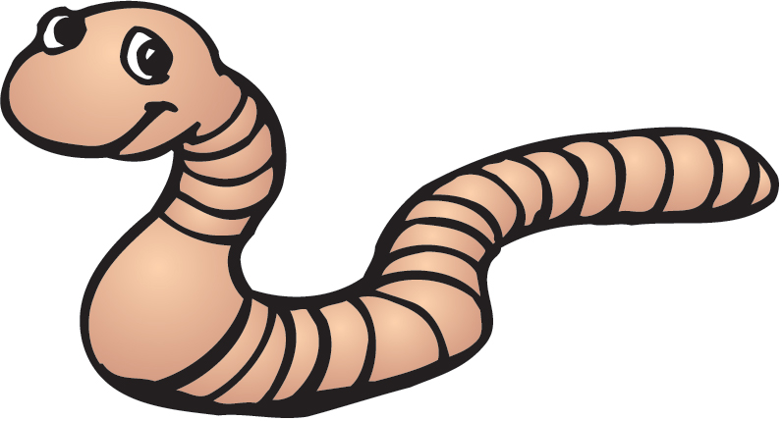The littlest worm, I ever saw,
Got stuck inside, my soda straw.

He said to me, “don’t take a sip”,
For if you’ll do, I’ll surely flip.

I took a sip, and he went down,
All through my pipes, he must have drowned

That is the end, there is no more,
Unless I see, that worm once more.

Are you sleeping, Brother John?

Are you sleeping?
Are you sleeping?
Brother John,
Brother John?
Morning bells are ringing,
Morning bells are ringing
Ding Ding Dong
Ding Ding Dong.

The numbers jump

Jump, jump the numbers jump
See what you can do
Be a kangaroo
Jump, jump the numbers jump
Everybody here we go
Jump one times
Jump two times
Jump three times
Counting as we go

Repeat chorus

Jump four times (that’s great)
Jump five times
Jump six times
Counting as we go

Repeat chorus

Jump seven times (higher!)
Jump eight times
Jump nine times (terrific!)
Jump ten times
Counting as we go

Lion hunt

Going on a lion hunt
Gonna catch a big one
Look at all the pretty flowers
Mighty fine days
Oh-oh a tree!
A big tall tree
Can’t go around it
Can’t go over it
I guess I’ll have to climb it!
Crick crack

Going on a lion hunt
...
Oh-oh a lake!
A big deep lake
I guess I’ll have to swim in it
...
Oh-oh a fence
...
Oh-oh a cave
A big dark cave
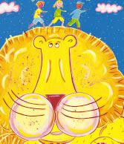Something furry
Long teeth
Long claws...
Ahhhhhhh! A lion!

The wheels on the bus

The wheels on the bus go round and round
Round and round, round and round
All the wheels on the bus go round and round
All around the town

The windows on the bus go up and down, up and down...
The doors on the bus go open and shut...
The wipers of the bus go swish swish swish...
The babies on the bus go boo hoo hoo...
The mothers on the bus go shh-shh-shh...
The driver of the bus says: “Please move back”...

My hat, it has three corners

My hat it has three corners
Three corners has my hat
And if didn’t have three corners
It wouldn’t be my hat
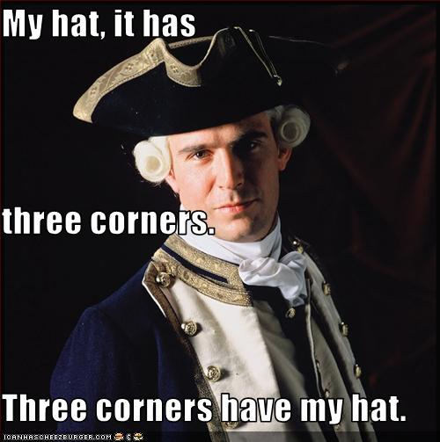

The Ants Go Marching

The ants go marching one by one
Hoorah! Hoorah!
The ants go marching one by one
Hoorah! Hoorah!
The ants go marching one by one;
The little one stops to suck his thumb
And they all go marching down into the ground

The ants go marching two by two
The little one stops to tie his shoe

The ants go marching three by three
The little one stops to climb a tree

The ants go marching four by four
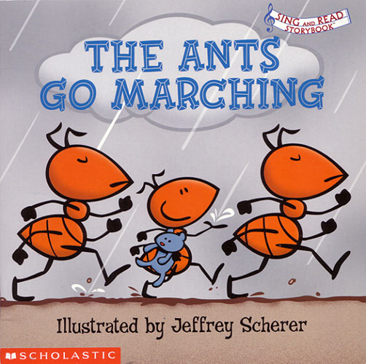The little one stops to shut the door

The ants go marching five by five
The little one stops to take a dive

The ants go marching six by six
The little one stops to pick up sticks

The ants go marching seven by seven
The little one stops to pray to heaven

The ants go marching eight by eight
The little one stops to roller skate

The ants go marching nine by nine
The little one stops to check the times

The ants go marching ten by ten
The little one stops to shout
“THE END!!”

Michael Finnagan

There was an old man named Michael Finnagan
He had whiskers on his chinnegan
They fell out and then grew in again
Poor old Michael Finnegan
Begin again

There was an old man named Michael Finnegan
He went fishing with a pinnegan
Caught a fish and dropped it in again
Poor old Michael Finnegan
Begin again

There was an old man named Michael Finnegan
He grew fat and then grew thin again
Then he died and had to begin again
Poor old Michael Finnegan
Begin again

The body dance

Bend your knees, touch your nose
Shake your head, stand on your toes
Open your eyes, so you can see
We’re doing the body dance, you and me

It doesn’t matter if your small
It doesn’t matter if your big
It doesn’t matter if you’re bald
Or if you wear a wig
Just...

Bend your knees, touch your nose
Shake your head, stand on your toes
Open your eyes, so you can see
We’re doing the body dance, you and me

It doesn’t matter if you’re thin
It doesn’t matter if you’re fat
Or if the colour of your skin
Is white, brown or black
Just...

Bend your knees, touch your nose
Shake your head, stand on your toes
Open your eyes, so you can see
We’re doing the body dance, you and me

The Toast song

All around the nation coast to coast
People always ask what I like most
I don’t like to brag I don’t like to boast
I just tell them I like toast

Yeah Toast! (2x)

Early in the morning 6 AM
Spread a little butter spread a little jam
You take two pieces and you put’em in the slots
You pull down the lever and the wires get hot

Yeah Toast! (2x)

If they tell you toasts are crummy
Laugh at them and call them dummies
And if they tell you toast is lame
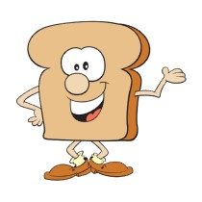Don’t mind them cause they’re insane

NOTES

Happy Days

Sunday, Monday, Happy Days,
Tuesday, Wednesday, Happy Days,
Thursday, Friday, Happy Days,
Saturday, what a day,
Rockin all week with you.

This days is ours
Won’t you be mine. (Oh Happy Days)
This day is ours (Oh Happy Days)
Oh please be mine.

Hello sunshine, goodbye rain,
She’s wearing my high school ring on her chain.
She’s my steady, I’m her man,
I’m gonna love her all I can.
(Chorus)
Gonna cruise her round the town,
Show everybody what I’ve found
Rock’n’roll with all my friends
Hopin’ the music never ends.

These Happy Days are yours and mine (Oh Happy Days)
These Happy Days are yours and mine (Oh Happy Days)
These Happy Days are yours and mine, Happy Days.

